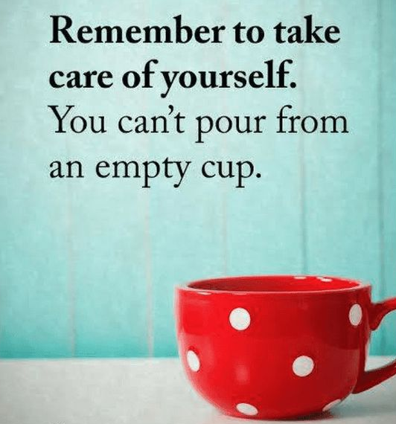
PSSP Staff Wellbeing Booklet

This ‘no screen’ booklet aims to give you some ideas for activities and practices to focus on your mental health and wellbeing. We hope you find it useful and find something here to help you to relax and take some time for you.
You are amazing!
Thank you for all you do.

10 wellbeing activities

Countdown to 5
Sit in a quiet space, try to clear your mind, and focus only on the following:
- 5 things you can see
- 4 things you can touch
- 3 things you can hear
- 2 things you can smell
- 1 thing you can feel

Feel the Fruit
This exercise aims to clear the mind of distractions and give all attention to the moment. Pick a piece of fruit and imagine it is entirely new to you. Consider:
- How it looks
- How it feels
- How it makes your skin feel
- How it smells
- How it tastes

Gratitude Wall
An activity to take note of something that you are grateful for and to ensure that those moments are acknowledged. Somewhere visible to you, post a note of something you are grateful for – it can relate to a person/an activity/something you have learned etc.

Breathing Box
This exercise aims to create focus on a single task, with no pressure related to outcome. The second part of the exercise encourages diaphragmatic breathing which is a calming practice used in Yoga.
- Using the net for the box (see appendix 1), cut out the template, decorate and colour the box before assembling.
- Once completed, lie on the floor, place the box on your waist. Focus on breathing in and out, counting the seconds of the inhalation and exhalation and watching the box slowly move up and down. Focus on using your diaphragm, where the belly lifts as much or instead of the rib cage.

Cardboard Creations
Wellbeing isn’t all about mental calm. It can also derive from playful activity, in a setting where there are no right or wrong answers. Using scissors/tape/cardboard boxes or anything else you have lying around, create a cardboard creation – this could be an animal/robot/ spaceship/furniture/vehicle etc - there are no right or wrong answers.

DIY Skincare
An Activity designed to keep focus and provide a sensory experience. This activity will also allow you to create something you can use later. Water is the enemy of a homemade sugar scrub so make sure you store it somewhere dry.
Sugar Scrub Recipe:
- 1 jar with lid
- 3 parts course sugar
- 1 Part Olive Oil
- 15-20 drops of your favourite essential oil

Walk and Talk
Walking meetings can be a powerful way to change the context from an overfamiliar learning setting. It is also a great opportunity to get moving while staying on task.

Mindful Walking
Walking can help you to reset the mind after periods of work. This is an observational exercise to focus on the moment and see what we do not normally notice.
- As you walk, try to recognise individual qualities of your environment: colours and shapes/light and darkness/sounds and smells/textures and sensations on your skin etc.

Disco in the Dark
Choose an upbeat song, turn all the lights off and close the curtains. Boogie away without any inhibitions.

10.Quiet Space
Find a quiet space with a comfortable seat, low lighting and a blanket (if it is chilly). Choose one/some of the abstract art work to place around the room. Focus on nothing but the art: look at the colours/brush strokes/how it makes you feel/what words come to mind. See appendices 2/3/4.

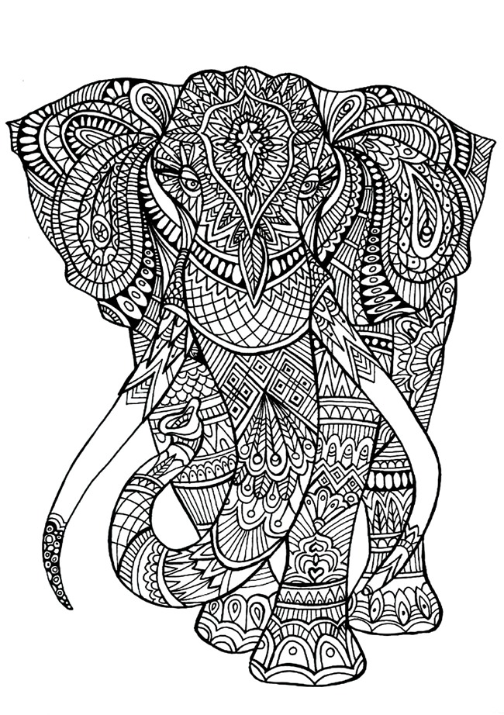
Adult Colouring
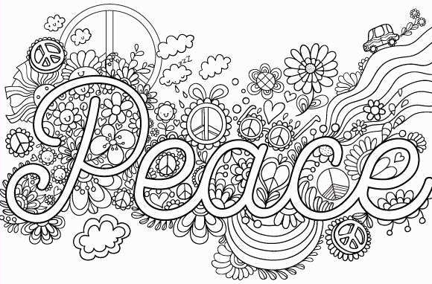
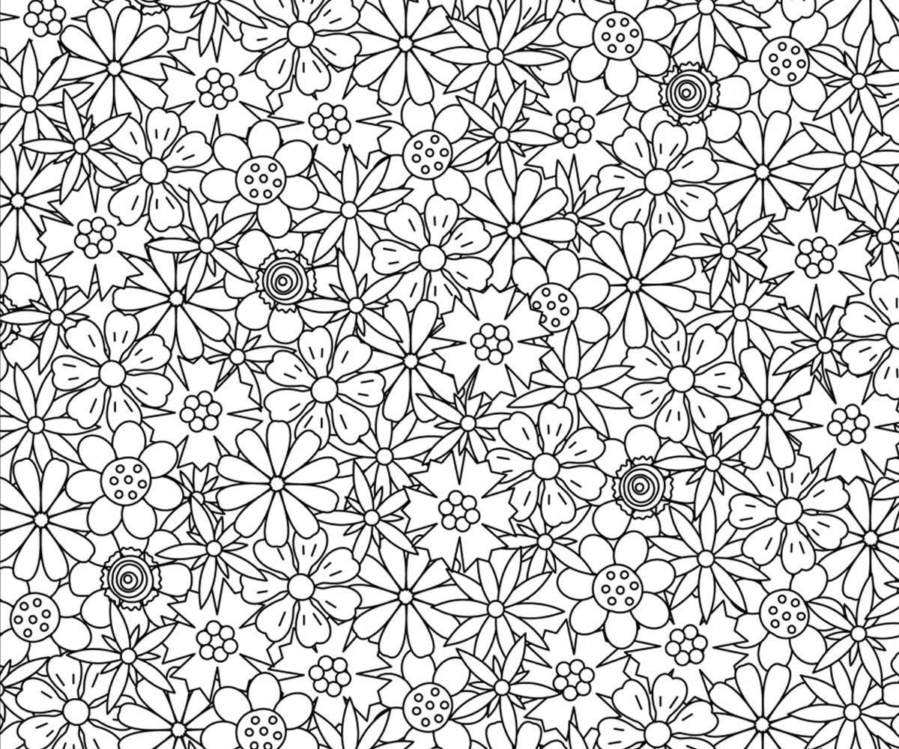

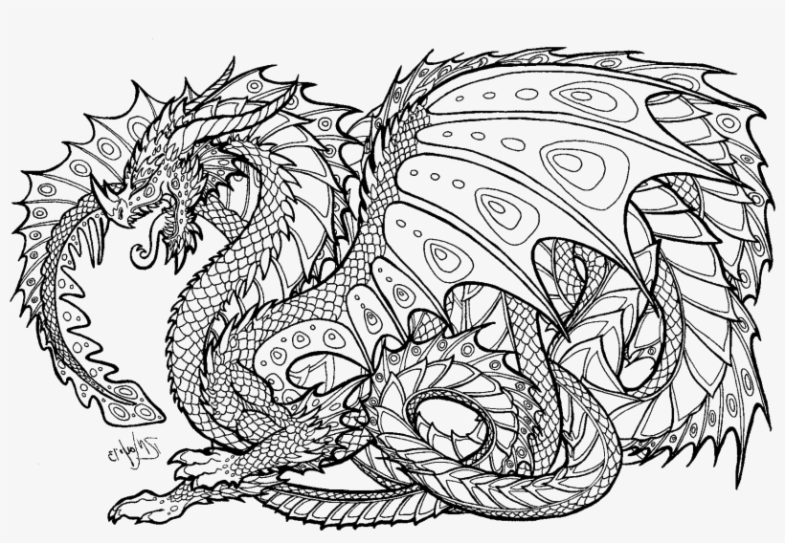

Put on some calming music and try some Yoga.
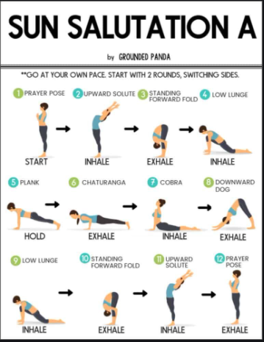

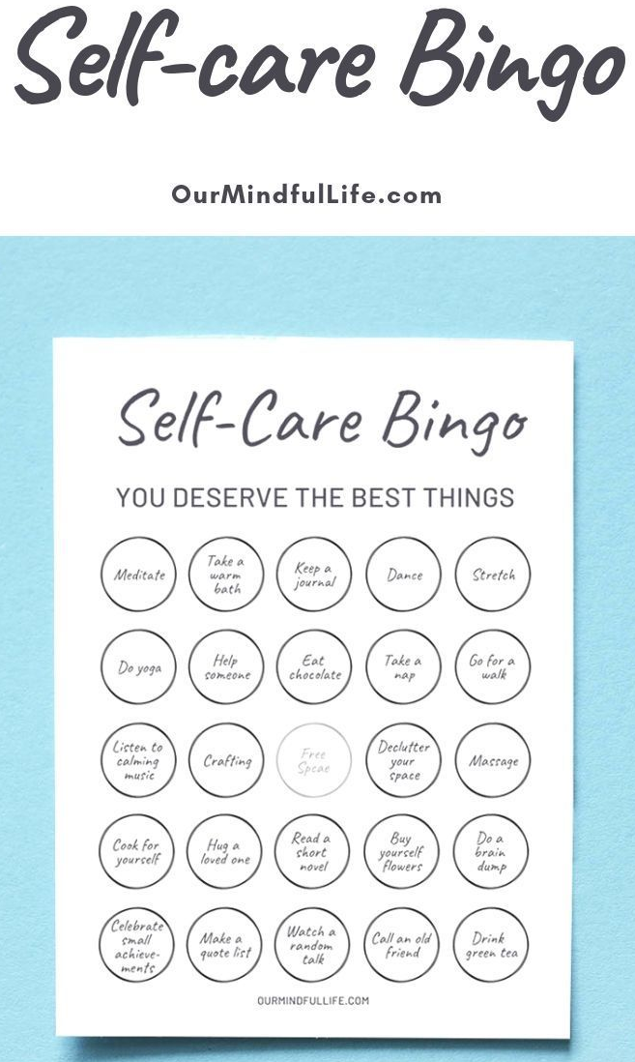

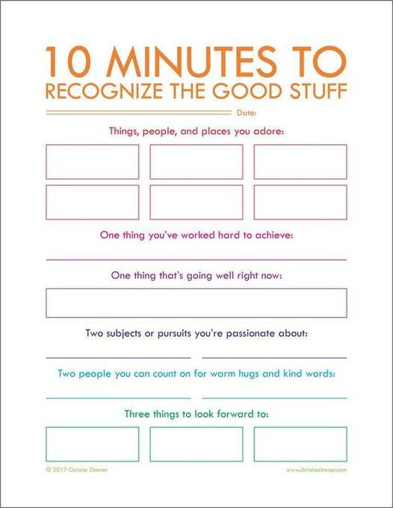

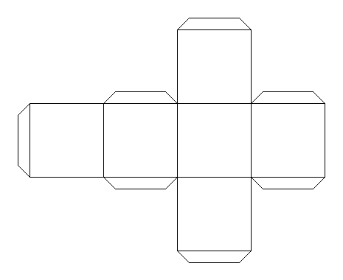
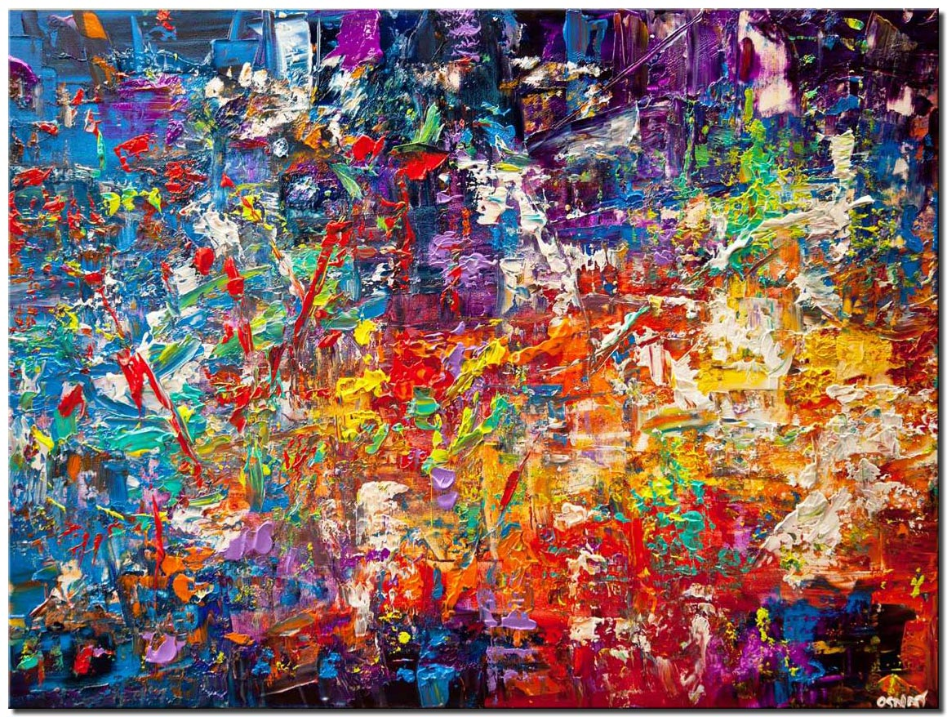
Appendix 1
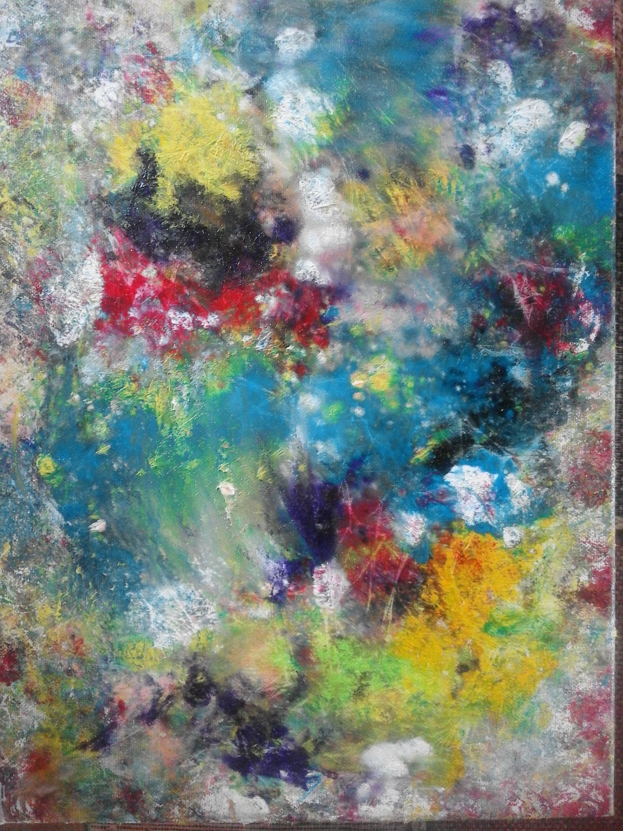
Appendix 2
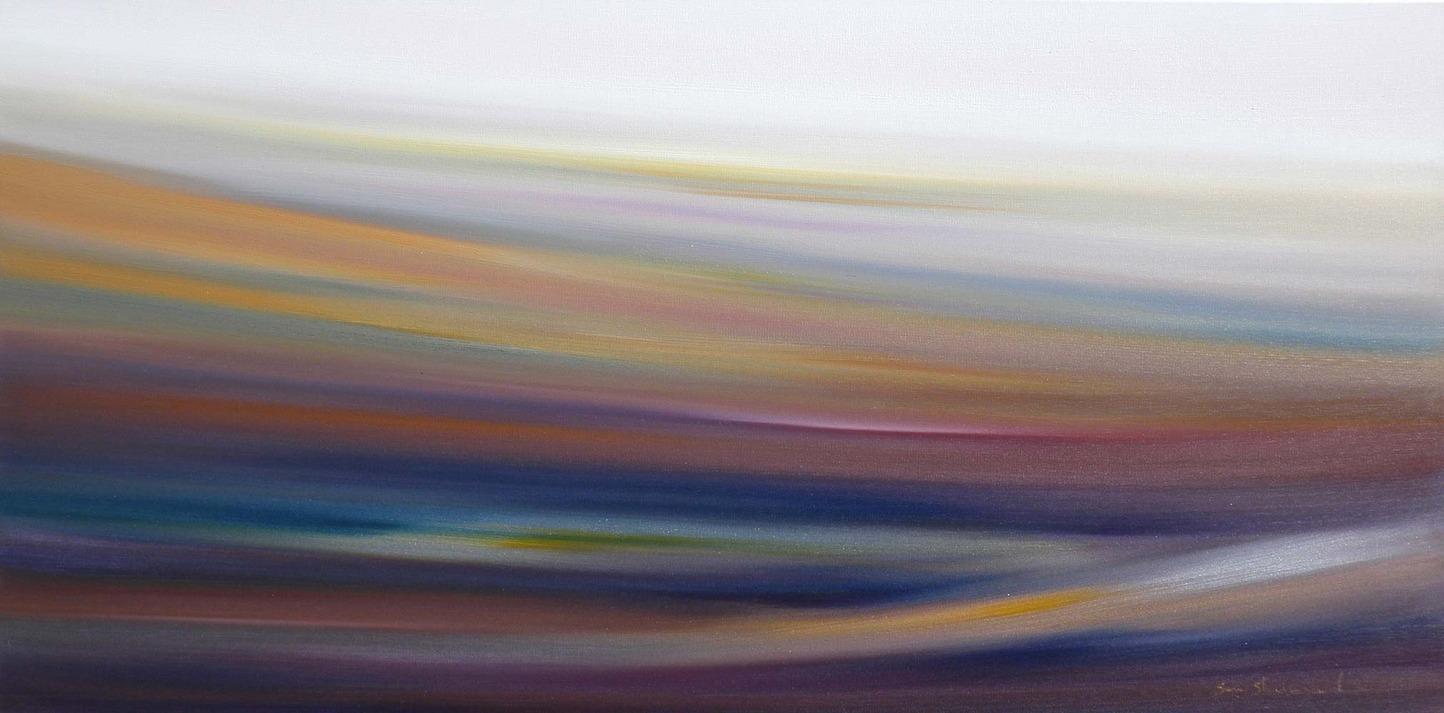
Appendix 3

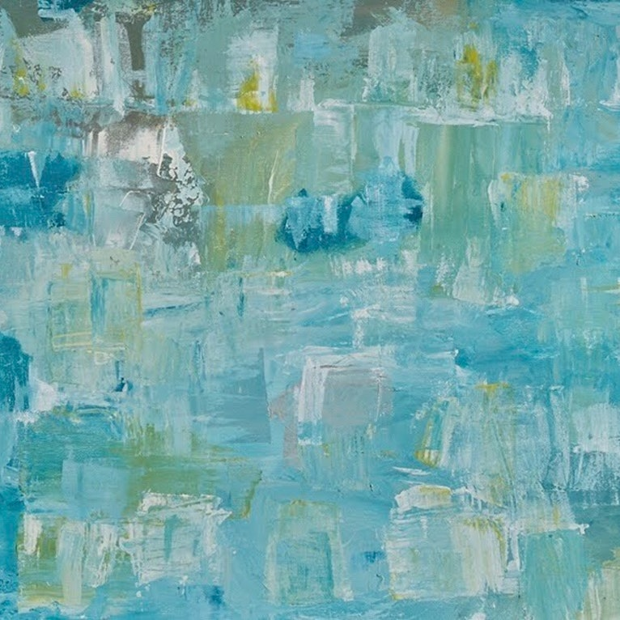
Appendix 4

