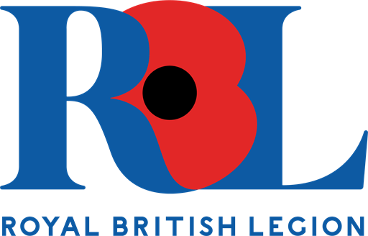

MKC Heroes Armed Forces Day Virtual Badge Competition 2021

The past year has brought many changes and challenges. It has certainly been a year we won’t forget! And, as we’re heading towards a brighter future, we’d like to celebrate by opening up this year’s Armed Forces Day competition.

As you may appreciate, circumstances are still not assured so we’ve taken the decision to create a virtual badge competition this year, with the winning creation being displayed on Plymouth’s Armed Forces website.

Entries should be sent digitally (a clear picture or scan of the drawing) to MKC Heroes – mkcheroes@britishlegion.org.uk by 21st May 2021.
Please include the form on the 2nd page of this document along with your image.

- Aim for a simple, bold design that includes the words: Armed Forces Day 2021.
- Use A4 paper and send to mkcheroes@britishlegion.org.uk
- Your badge may be any shape and colour.
- Think about the Armed Forces taking part.
- Please do not include images of guns or fighting.

Entry Form

Name………………………………………….

Age……………………………..

School/Parent/Carer Contact Name…………………………..
……………………………………………………………………….

Contact Details……………………………………………………

Please send this form, along with your design to mkcheroes@britishlegion.org.uk

*The winning designer may be asked, by the Royal British Legion and local media, to contribute towards publicity for the event, including photographs and, potentially, video/TV. Parental permission will be required and sought as appropriate.

